

NAME : LOKESH S
REG NO : 192572151
COURSE CODE : CSA0624
COURSE : DESIGN AND ANALYSIS OF ALGORITHMS

Experiment 1: Sum of Array Elements

Question
Write a Python program to find the sum of all elements in an array.

Aim
To calculate the sum of the given array elements using a loop.

Algorithm
- Start the program.
- Read the number of elements n.
- Read n array elements.
- Initialize sum = 0.
- Repeat through every array element.
- Add each element to sum.
- Display the final sum.
- Stop the program.

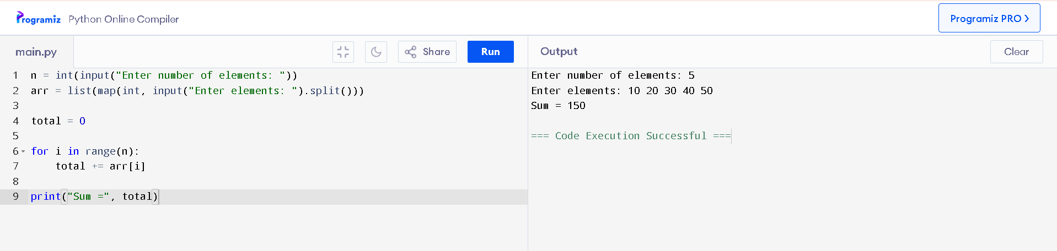

Result
Thus, the Python program to find the sum of array elements was executed successfully.

Experiment 2: Sum of First N Natural Numbers

Question
Write a Python program to find the sum of the first n natural numbers.

Aim
To calculate the sum of the first n natural numbers using iteration.

Algorithm
- Start the program.
- Read the value of n.
- Initialize sum = 0.
- Repeat from 1 to n.
- Add the current number to sum.
- Display the value of sum.
- Stop the program.

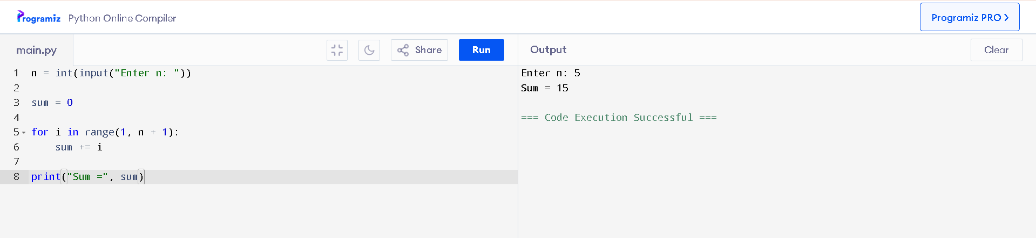

Result
Thus, the Python program to find the sum of the first n natural numbers was executed successfully.

Experiment 3: Linear Search

Question
Write a Python program to search for a given element in an array using linear search.

Aim
To implement linear search and find the position of a given key in an array.

Algorithm
- Start the program.
- Read the number of elements n.
- Read the array elements.
- Read the key to be searched.
- Compare the key with each array element from the beginning.
- If the key matches an element, display its position.
- If no element matches, display “Element not found.”
- Stop the program.
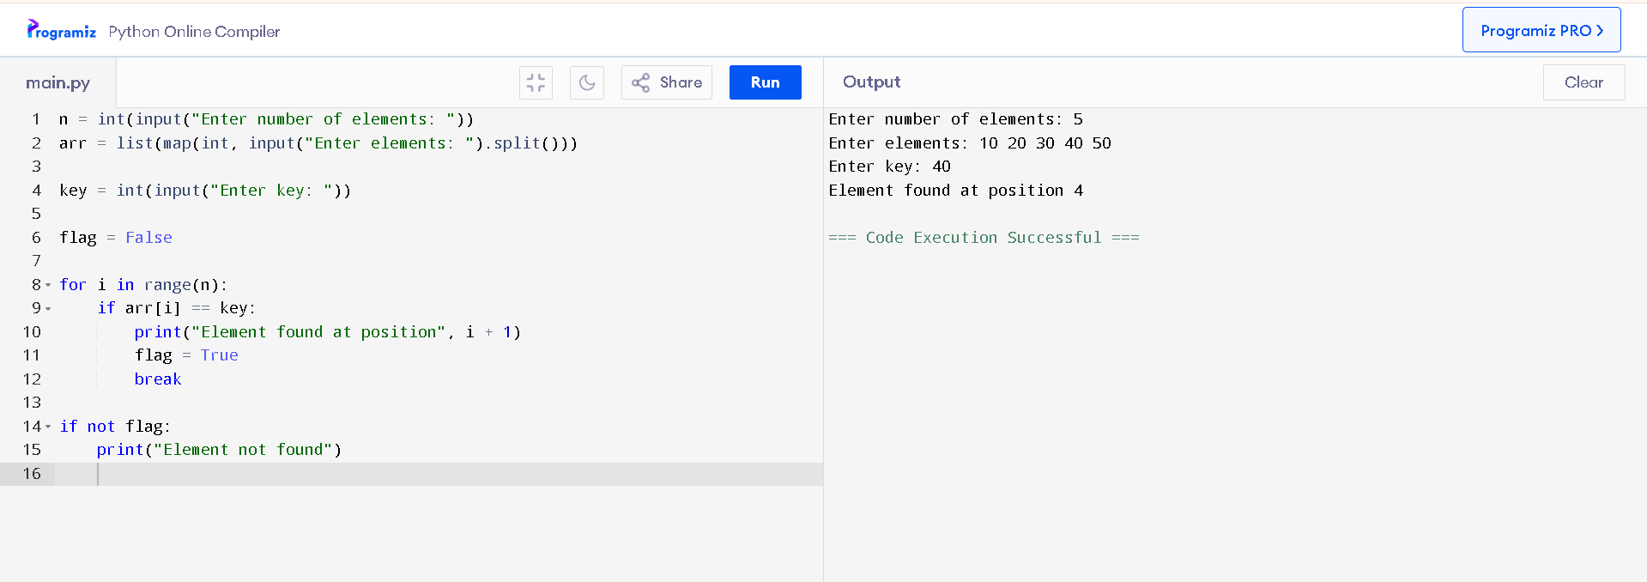

Result
Thus, the Python program to search for an element using linear search was executed successfully.

Experiment 4: Matrix Addition

Question
Write a Python program to add two matrices.

Aim
To perform the addition of two matrices of the same order.

Algorithm
- Start the program.
- Read the number of rows and columns.
- Read the elements of matrix A.
- Read the elements of matrix B.
- Create a result matrix C.
- For each row and column, calculate:
C[i][j] = A[i][j] + B[i][j]
- Display the resultant matrix.
- Stop the program.
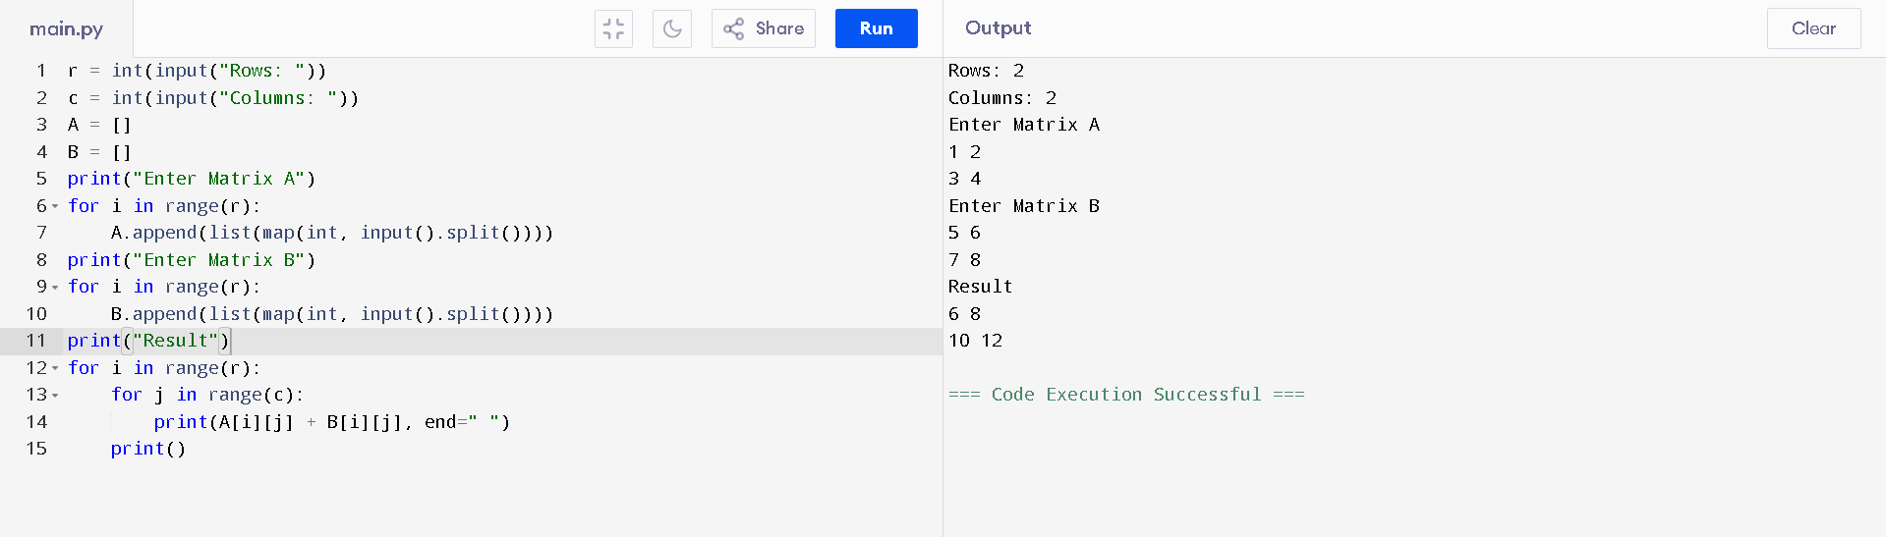

Result
Thus, the Python program to add two matrices was executed successfully.
Experiment 5: Matrix Multiplication

Question
Write a Python program to multiply two matrices.

Aim
To perform matrix multiplication using nested loops.

Algorithm
- Start the program.
- Read the rows and columns of matrix A.
- Read the rows and columns of matrix B.
- Check whether the number of columns in A equals to rows in B.
- Read the elements of both matrices.
- Initialize the result matrix with zeros.
- Use three nested loops to calculate:
C[i][j] = C[i][j] + A[i][k] × B[k][j]
- Stop the program.
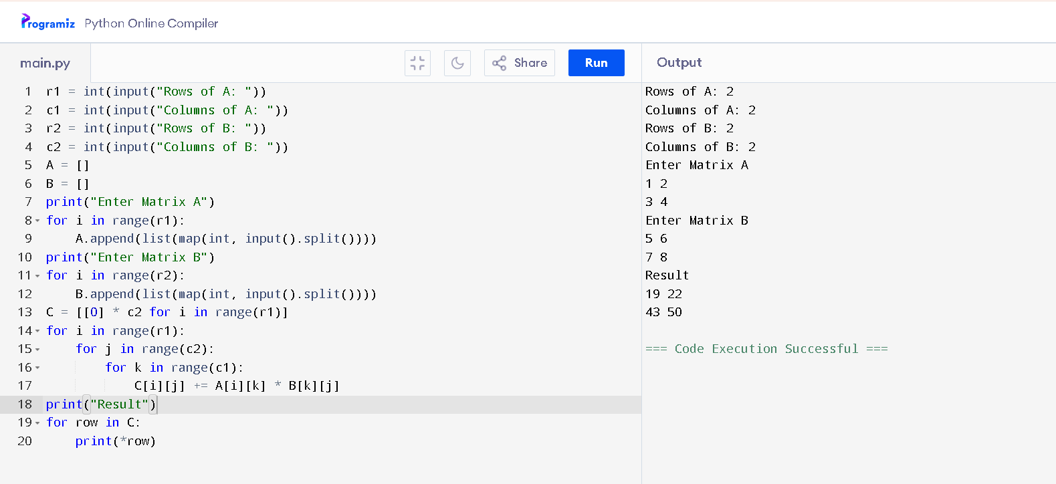

Result

Thus, the Python program to multiply two matrices was executed successfully.

Experiment 6: Constant-Time Complexity

Question
Write a Python program to demonstrate constant-time complexity.

Aim
To demonstrate an operation whose execution time does not depend on the input size.

Algorithm
- Start the program.
- Read a number n.
- Calculate the square of n.
- Display the result.
- Stop the program.
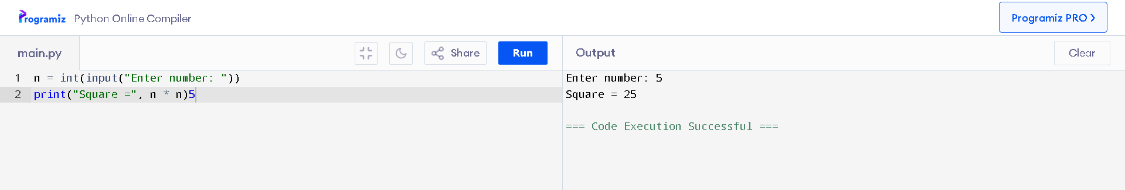

Result
Thus, the program demonstrating constant-time complexity O(1) was executed successfully.

Experiment 7: Logarithmic-Time Complexity

Question
Write a Python program to demonstrate logarithmic-time complexity.

Aim
To demonstrate logarithmic growth by repeatedly multiplying a value by two.

Algorithm
- Start the program.
- Read the value of n.
- Initialize i = 1.
- Repeat while i ≤ n.
- Display i.
- Update i = i × 2.
- Stop when i becomes greater than n.
- Stop the program.
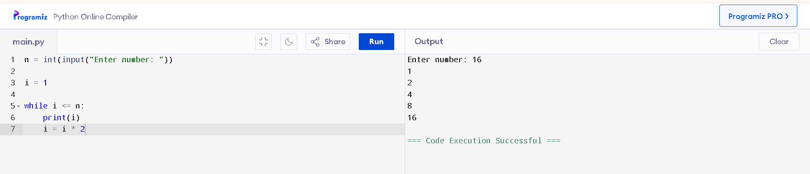

Result
Thus, the program demonstrating logarithmic-time complexity O(log n) was executed successfully.

Experiment 8: Linear-Time Complexity

Question
Write a Python program to demonstrate linear-time complexity.

Aim
To demonstrate an algorithm in which the number of operations increases linearly with the input size.

Algorithm
- Start the program.
- Read the value of n.
- Repeat from 1 to n.
- Display the current value.
- Stop the program.
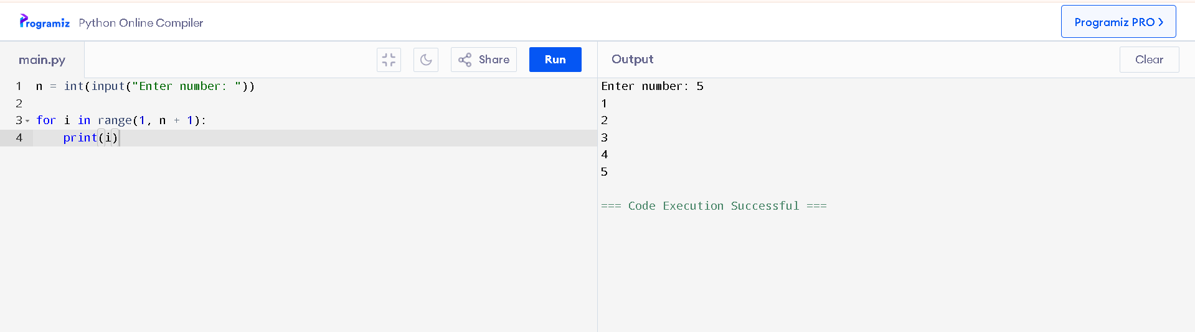

Result
Thus, the program demonstrating linear-time complexity O(n) was executed successfully.

Experiment 9: Quadratic-Time Complexity

Question
Write a Python program to demonstrate quadratic-time complexity.

Aim
To demonstrate quadratic complexity using two nested loops.

Algorithm
- Start the program.
- Read the value of n.
- Execute an outer loop from 1 to n.
- For every outer-loop iteration, execute an inner loop from 1 to n.
- Display the values of the two loop variables.
- Stop the program.
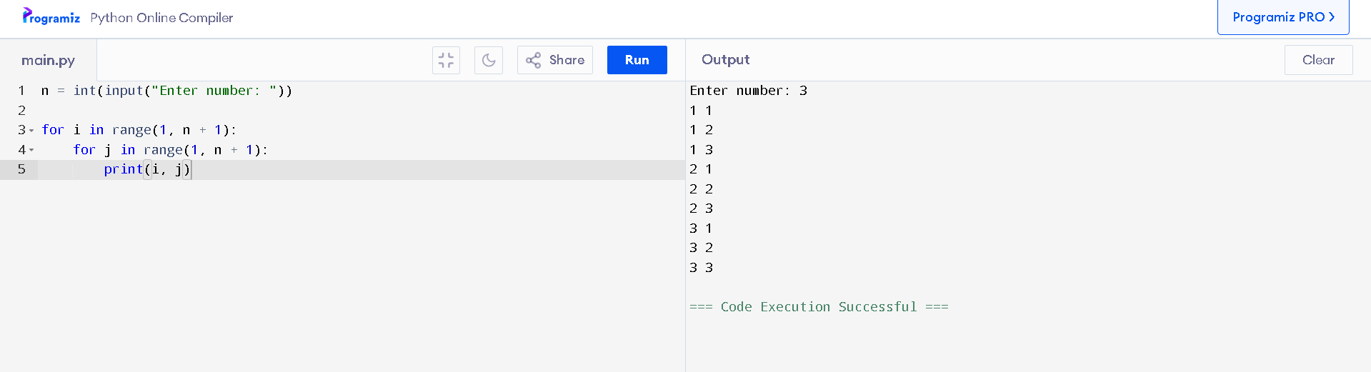

Result
Thus, the program demonstrating quadratic-time complexity O(n²) was executed successfully.

Experiment 10: Cubic-Time Complexity

Question
Write a Python program to demonstrate cubic-time complexity.

Aim
To demonstrate cubic complexity using three nested loops.

Algorithm
- Start the program.
- Read the value of n.
- Execute the first loop from 1 to n.
- Execute the second loop from 1 to n.
- Execute the third loop from 1 to n.
- Display the values of all three loop variables.
- Stop the program.
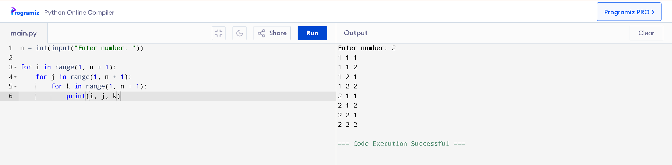

Result
Thus, the program demonstrating cubic-time complexity O(n³) was executed successfully.

